**PARTNERSHIP PROPOSAL**



**Prepared By:**

**GOD SON FACILITY MANAGEMENT & CONSULTANCY SERVICES**

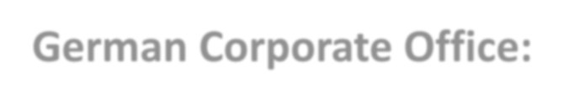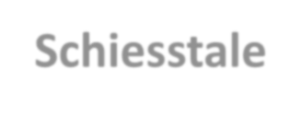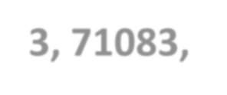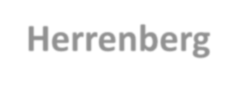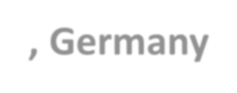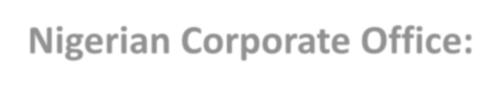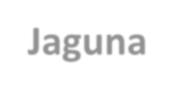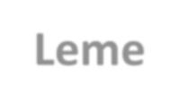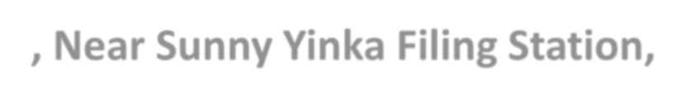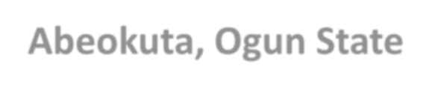

**German Corporate Office:**

**Schiesstale 3, 71083, Herrenberg, Germany**

**Nigerian Corporate Office:**

**Jaguna Leme, Near Sunny Yinka Filing Station, Leme,**

9/21/2015 9:04:56 AM **Abeokuta, Ogun State** 1

# OBJECTIVE OF THE PROPOSAL

Dear Prospective Partner,

The primary objective of this proposal is to secure a financial partnership with you/your organization to support the procurement of essential equipment for our Cleaning Agency, **God Son Facility Management & Consultancy Services.** This partnership will enable us to significantly enhance our cleaning operations, improve service quality, and expand our client base, ultimately leading to increased profitability and sustainability for both our organizations.

**SpecificObjectives:**

1. **Equip our Agency with State-of-the-Art Cleaning Technology:** By securing funding from your esteemed organization, we aim to acquire advanced cleaning equipment such as listed under the proposed procurement table. This will significantly improve the efficiency and effectiveness of our cleaning services, allowing us to handle larger and more complex projects.
2. **Enhance Service Quality and Client Satisfaction:** With superior equipment, our cleaning teams will be able to deliver a higher standard of service, exceeding client expectations and building long-term relationships. This will lead to increased client retention and positive wordof-mouth referrals, further boosting our business growth.
3. **Expand our Client Base and Market Reach:** Improved capabilities and service quality will allow us to tap into new market segments and attract larger clients with more demanding cleaning needs. This expansion will generate additional revenue streams and solidify our position as a leading cleaning service provider in Lagos.
4. **Demonstrate Financial Viability and Return on Investment:** This proposal will outline a clear financial plan detailing the cost of equipment acquisition, projected revenue growth, and the anticipated return on investment for your partnership.

**Mutual Benefits:**

By partnering with us, you will benefit from:

1. **Return on Investment:** Expectedly, more equipment will give us more return on investment which will be shared by us in accordance to our mutually signed agreement.
2. **Positive Brand Association:** Your organization will be associated with a reputable and successful cleaning agency, enhancing your corporate image and community engagement.
3. **Increased Visibility and Reach:** Your logo and brand will be displayed on our cleaning equipment and promotional materials, expanding your reach and brand awareness in Lagos.
4. **Fulfillment of Social Responsibility Goals:** By supporting our agency's environmental sustainability initiatives through efficient cleaning practices, your organization will contribute to a cleaner and healthier Nigeria.

**Conclusion:**

This partnership proposal presents a mutually beneficial opportunity for you and us. By securing your financial support, we can achieve our objective of acquiring advanced cleaning equipment, enhancing our service quality, expanding our client base, and ultimately generating increased profitability and sustainability for both our organizations. We are confident that this collaboration will be a success, contributing positively to the Nigeria cleaning industry. ***SIGNED:***

**Adedapo Adedeji Akiode**

FOUNDER/CEO

+234 (0) 802 358 8767

+49 1521 5341962

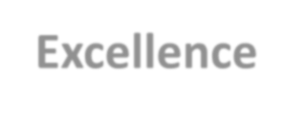

**Excellence**

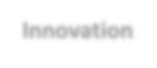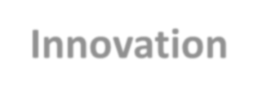

**Innovation**

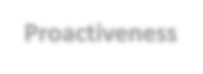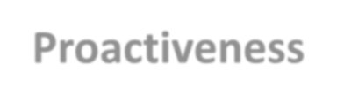

**Proactiveness**

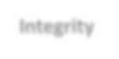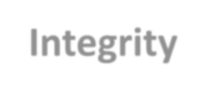

**Integrity**

**Excellence**

**:**

**Providing**

**the**

**highest**

**quality**

**cleaning**

**services**

**and**

**exceeding**

CORE VALUES

**customer expectations.**

**Reliability: Being punctual, dependable, and delivering consistent results. Trustworthy: Maintaining confidentiality and protecting customer property and privacy.**

**Responsiveness: Being attentive to customer needs and addressing concerns promptly.**

**Personalization: Tailoring cleaning services to individual customer**3 **preferences**

## COMPANY PROFILE



**God Son Facility Management and Consultancy Services** is a cleaning company established out of the passion and desire to have a cleaner and more healthier environment in Nigeria.

The founder having gained international experience in professional cleaning from his long years in Germany, came home to Nigeria to establish God Son Facility Management and Consultancy Services (GSFMCS) in 2018 .

This company is an offshoot of the Cleaning Company established in the city of Fellbach in Germany. The company specializes in all manners of cleaning (interior and exterior) including but not limited to:

1. Waste Management
2. Basic Cleaning
3. Industrial Cleaning
4. Refrigeration Cleaning
5. Maintenance Cleaning
6. Construction Cleaning
7. Hazardous Waste Disposal
8. Sewage Disposal and many others

**Our Vision:**

* To be the premier provider of facility management and consultancy services in Nigeria, driven by integrity, innovation, and exceptional customer service, while upholding deep ethical principles in our conduct.

**Our Mission:**

* To empower our clients to achieve optimal operational efficiency and asset value through customized facility management solutions, delivered with professionalism, technical expertise, and unwavering commitment to their needs.
* To foster a dynamic and values-driven work environment where employees are empowered to excel, contributing to the growth of the company and the betterment of the communities we serve.

**Our Values:**

* **Integrity:** We conduct ourselves with honesty, transparency, and ethical principles in all our dealings, earning the trust and respect of our clients, employees, and stakeholders.
* **Innovation:** We embrace creativity and continuous improvement, seeking new and effective solutions to enhance the value we deliver to our clients.
* **Excellence:** We strive for the highest standards in everything we do, exceeding expectations and delivering exceptional results.
* **Client Focus:** We are committed to understanding and exceeding our clients' needs, building long-term partnerships based on mutual trust and collaboration.
* **Employee Empowerment:** We value our employees as our greatest asset, fostering a culture of growth, development, and recognition.
* **Social Responsibility:** We recognize our role in contributing to the well-being of the communities we serve, engaging in responsible business practices and supporting worthy causes.
* **Faith:** We operate with a strong religious values, guiding our decisions and actions with honesty, compassion, and service to others.

# PROFILE OF THE CEO

**Adedapo Adedeji Akiode** is the Chief Executive Officer of God Son Facility Management & Consultancy Services & Hoffnung (Hope) Sports Foundation (HSF) targeted at encouraging sports participation in primary and secondary schools in Ogun State.

**CEO**



COMPETENC

E



CAPACITY

CHARACTER

CAPABILITY

He believes in using sports to develop the youths and to encourage the less privileged youths in the society to pursue a bright and radiant future. Over a period of years, he has sponsored a number of sporting talents and hosted various sporting activities in Ogun State and beyond.

He has played in a number of clubs both home and away.

Notable among these clubs are DJK Germania Lenkerbeck, TUS 09 Warstein, TSV Kuppingen, DJK Sportbund Stuttgart and TV Dornstetten all in Germany.

**Dapo Akiode** is a man with a mission: to make Nigeria sparkle. As the CEO of **God Son Facility Management & Consultancy Services**, he is leading the charge in providing top-quality cleaning services to homes, businesses, and institutions throughout the city. But Dapo's commitment goes beyond just clean floors and sparkling windows. He is also passionate about giving back to the community and making a difference in the lives of others.

## From Humble Beginnings to Entrepreneurial Success

Dapo's journey began in the bustling cities of Lagos, Nigeria & Herrenberg, Germany. He grew up in a family that valued hard work and dedication, and these values have stayed with him throughout his life. After completing his education, Dapo entered the workforce with a determination to succeed. He quickly recognized the need for high-quality cleaning services in Lagos, and in 2018, he founded God Son Facility Management & Consultancy Services.

## Building a Reputable Business

God Son Facility Management & Consultancy Services has grown from a small startup to a thriving business, thanks to Dapo's leadership and vision. He has built a team of experienced and dedicated cleaning professionals who are committed to providing exceptional service. Dapo is also a stickler for quality, and he has implemented strict standards and procedures to ensure that every job is done to the highest possible standard. ***More Than Just Cleaning***

For Dapo, God Son Facility Management & Consultancy Services is more than just a business. It is an opportunity to make a positive impact on the community. He is committed to employing local residents and providing them with fair wages and benefits. Dapo also supports a number of local charities and organizations, and he is always looking for ways to give back.

## A Bright Future Ahead

Under Dapo's leadership, God Son Facility Management & Consultancy Services is poised for continued growth and success. The company has a strong reputation for quality and reliability, and it is constantly expanding its services to meet the needs of its clients. Dapo is also committed to innovation, and he is always12/27/2023 7:43:27 PMlooking for new ways to improve his business and make a difference in the world. 6He is a successful businessman, a dedicated community leader, and a role model for young people everywhere.

His story is one of hard work, perseverance, and a genuine desire to make the world a better place.

## PROCUREMENTS

|  |  |  |  |  |
| --- | --- | --- | --- | --- |
| **S/N** | **NAME OF EQUIPMENT** | **QUANTITY** | **UNIT COST** | **AMOUNT (NGN)** |
|  |  |  |  |  |
|  |  |  |  |  |

# SWOT ANALYSIS



**STRENGHTS**

Forthright Leadership with

Experience and Expertise..

Exposure to International Best

Practices



**WEAKNESS**

Inadequate Source of Equity Financing

Obsolete Tool, Machineries & Equipment



**OPPORTUNITIES**

* Availability & Abundance of Prospective

Clients

• High Growth Tendencies

High Revenue Generation Prospect

* Available Workforce

*Aggressive Marketing Channels

*Improved Innovations



**THREATS**

*Fluctuating Cost of

Material Importation .

* Predilection to crude

methodology by Facility

owners.

* Poor Legislation on

Waste Management



**SWOT**

***Annexure: All efforts should be geared to effectively combat and minimize our threats and weaknesses to the bearest minimum*.**

12/27/2023 7:43:28 PM 8

***Many people fail in life, not for lack of ability or***

***brains or even courage but simply because***

***they have never***

***organized their***

***energies around a goal***

***- Elbert Hubbard***

**We invite you to invest in more than just a facility management company; we invite you to invest in a team driven by excellence, integrity, and a passion for making a difference.**

**At God Son Facility Management & Consultancy Services, we constantly evolve, embrace innovation, and strive to be the best in our field. Partner with us, and together let's navigate the ever changing landscape of facility management, achieving mutual success while staying true to our core values and making a positive impact on the communities we serve.**

**Thank you and please accept the assurances of my highest regards.**

***SIGNED:***

**Adedapo Adedeji Akiode**

FOUNDER/CEO

12/27/2023 7:43:28 PM 9